**ANACONDA INSTALLATION**

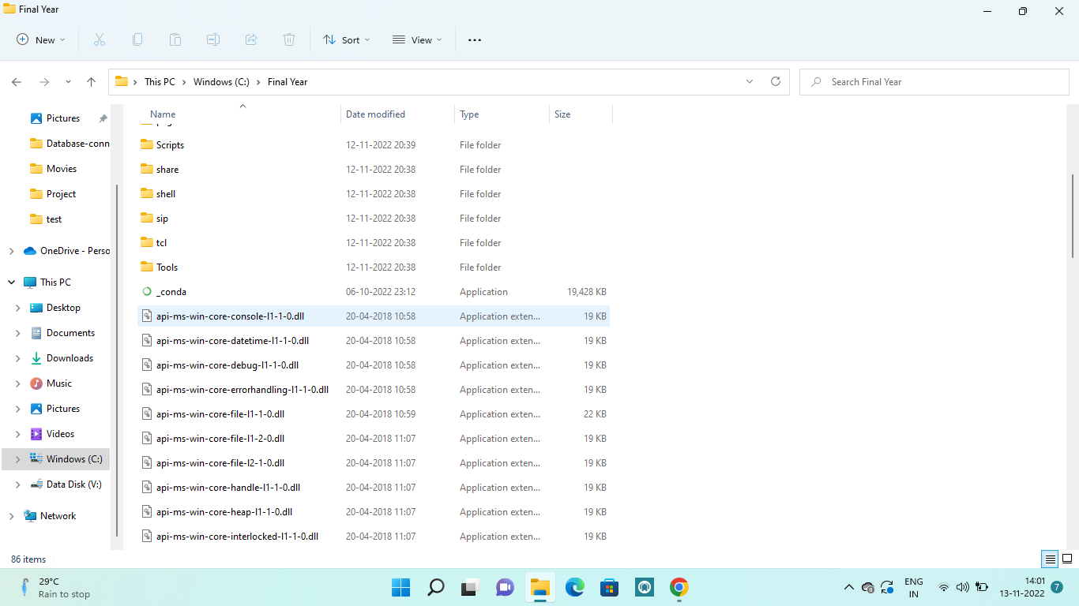

**PYTHON PACKAGES INSTALLATION**

